**Observable 1:**

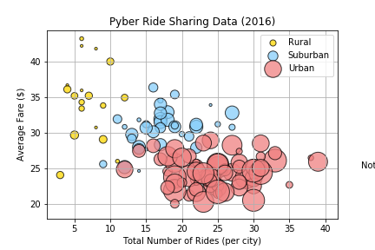

It seems that there is a correlation between the city type and the number of rides:

Urabn type settlements has the highest number of rides

**Observable 2:**



It seems that there is a correlation between the city type and the average fare :

Rural type settlements has the highest highest fares

**Observable 3:**

The settlements considered urban has the highest number of drivers

